**Open vs Closed Systems**

* Thermodynamics is a branch of science that explains the energy transfer between objects and their surrounding.
* System and surrounding are two basic terms used in thermodynamics. A system is a part of the universe that is being studied and surrounding is the rest of the universe other than that particular system. The margin of the system which separates it from the surrounding is called boundary.
* Systems can exist in three ways open systems**,** closed systems**,** andisolated systems. The main difference between an open and closed system is that in an open system, matter can be exchanged with the surroundings whereas, in a closed system, matter cannot be exchanged with the surrounding.

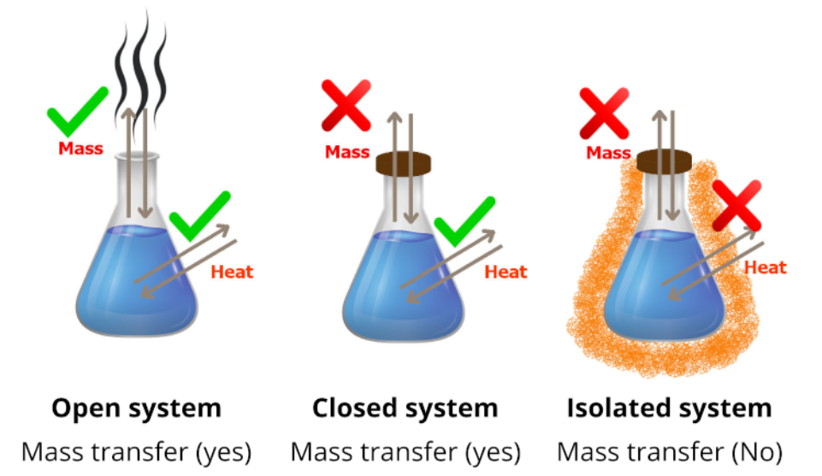

**Definitions**

**Open System:** An open system is a system where energy and matter can be exchanged with its surrounding.

**Closed System:** A closed system is a system where energy can be exchanged with its surrounding but not matter.

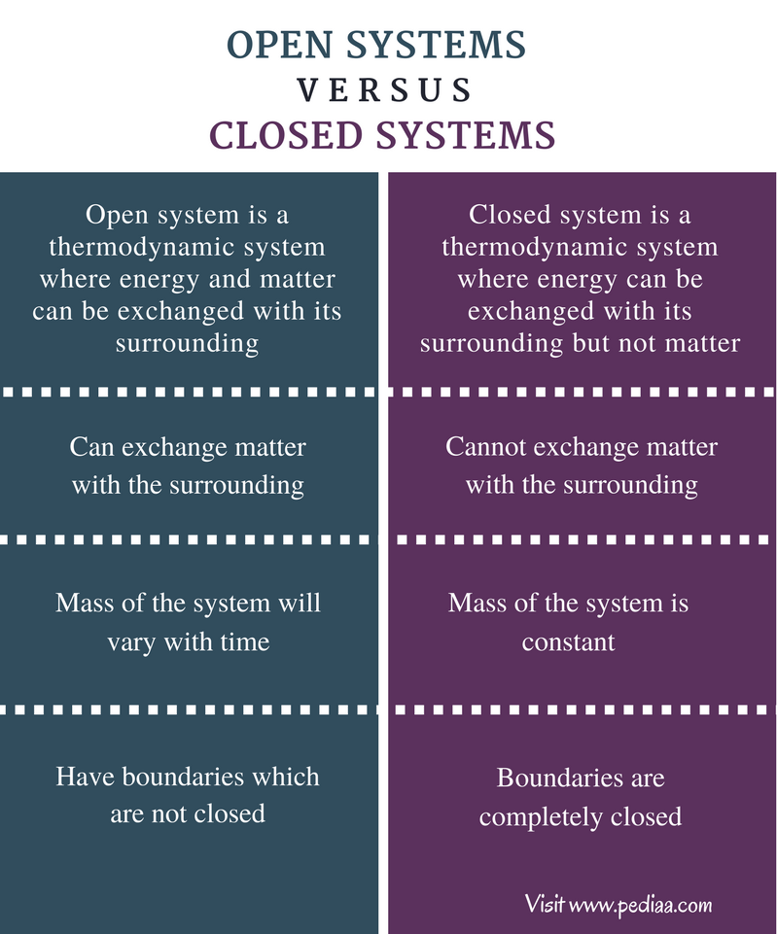

**For more detail refer to:**

<https://pediaa.com/difference-between-open-and-closed-system/>